EXP NO 1
Transformation between Cartesian, Cylindrical and Spherical Coordinate Systems

Aim
To write a MATLAB program for transformation between Cartesian, Cylindrical and Spherical coordinate systems

Objectives
1.To understand the mathematical relationships between Cartesian, Cylindrical and Spherical coordinate systems.
2.To develop a MATLAB program that converts the position of an object from one coordinate system to another.
3.To verify the correctness of the coordinate transformation by comparing computed values against standard analytical formulas.

Cartesian to Cylindrical and Spherical Coordinates
clc;
x=input('Enter the value of X=');
y=input('Enter the value of y=');
z=input('Enter the value of z=');
% Cartesian to Cylindrical
rho=sqrt(x^2+y^2);
phi=atan2d(y,x);
disp('Cartesian to cylindrical coordinate system of p(rho,phi,z)=');
disp([rho phi z]);
% Cartesian to Spherical
r=sqrt(x^2+y^2+z^2);
theta=acosd(z/r);
phi=atan2d(y,x);
disp('Cartesian to spherical coordinate system of s(r,theta,phi)=');
disp([r theta phi]);

OUTPUT
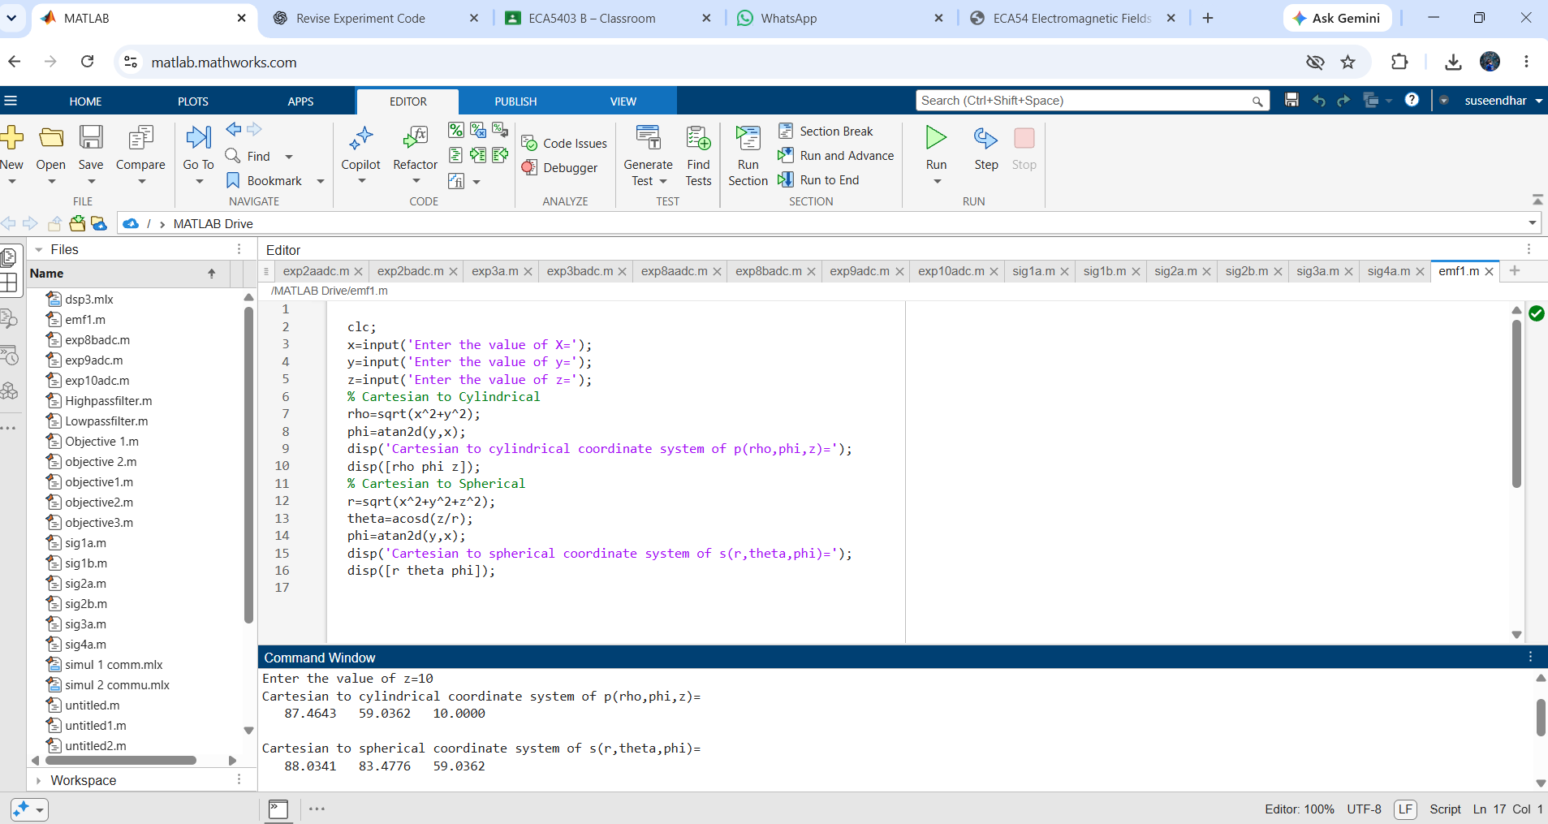

Cylindrical to Cartesian and Spherical Coordinates

clc;
rho=input('Enter the value of rho=');
phi=input('Enter the value of phi=');
z=input('Enter the value of z=');
% Cylindrical to Cartesian
x=rho*cosd(phi);
y=rho*sind(phi);
disp('Cylindrical to Cartesian coordinate system of p(x,y,z)=');
disp([x y z]);
% Cylindrical to Spherical
r=sqrt(rho^2+z^2);
theta=acosd(z/r);
disp('Cylindrical to spherical coordinate system of s(r,theta,phi)=');
disp([r theta phi]);

OUTPUT
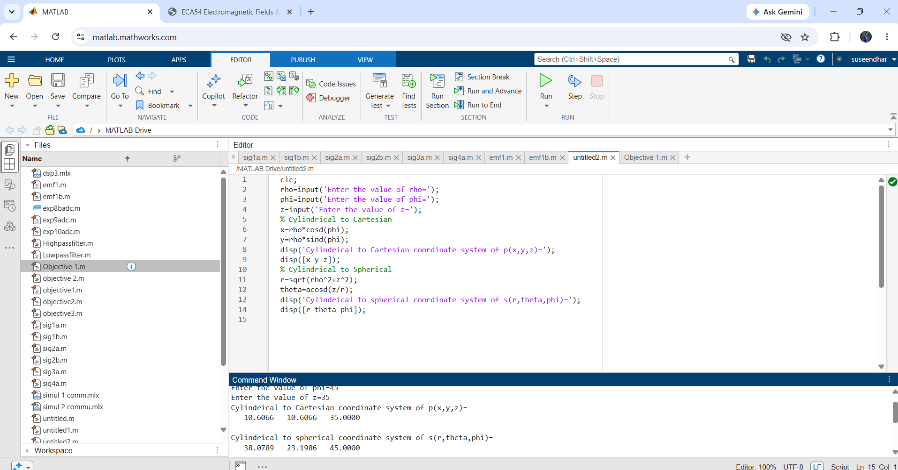

Spherical to Cartesian and Cylindrical Coordinates

clc;
r=input('Enter the value of r=');
theta=input('Enter the value of theta (deg)=');
phi=input('Enter the value of phi (deg)=');
% Spherical to Cartesian
x=r*sind(theta)*cosd(phi);
y=r*sind(theta)*sind(phi);
z=r*cosd(theta);
disp('Spherical to Cartesian coordinate system of p(x,y,z)=');
disp([x y z]);
% Spherical to Cylindrical
rho=r*sind(theta);
disp('Spherical to cylindrical coordinate system of s(rho,phi,z)=');
disp([rho phi z]);

OUTPUT
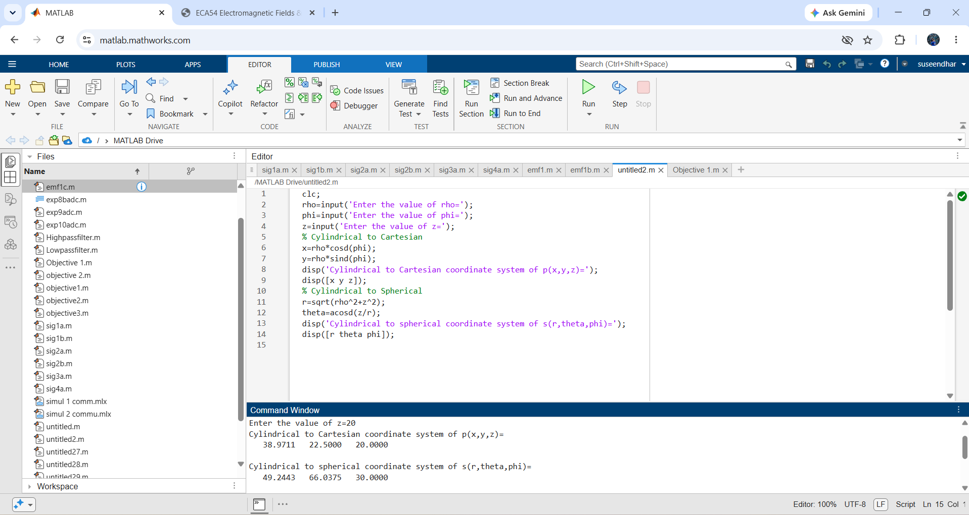

S. No. | Objective | Assessment Criterion | Excellent – 4 | Good – 3 | Satisfactory – 2 | Needs Improvement – 1 | Weighting (%) | Marks given | Marks obtained
1 | Apply coordinate-system definitions and angle conventions | Apply coordinate-system definitions, symbols, units, and angle conventions | Applies coordinate-system definitions and angle conventions throughout. | Uses correct definitions with one minor notation or convention error. | Shows partial understanding; multiple corrections are needed. | Uses incorrect coordinate definitions or angle conventions. | 25 | 2.5
2 | Implement transformations in MATLAB | Implement six transformations in MATLAB | Implements all six transformations correctly using suitable degree-based functions. | Implements most transformations correctly with minor coding errors. | Implements some transformations but needs assistance to correct errors. | Unable to implement the required transformations. | 25 | 2.5
3 | Verify numerical values and reverse transformations | Verify numerical values and reverse transformations | All outputs agree with analytical values; reverse transformations recover the original point within rounding precision. | Most values agree; small unexplained differences occur. | Several values differ or reverse verification is incomplete. | Outputs are incorrect or not verified. | 30 | 3
4 | Interpret and document results | Interpret and document results | Presents complete tables, units, deviations, and a clear conclusion. | Documentation is clear with minor omissions. | Tables or interpretation are incomplete. | Results and conclusion are missing or unclear. | 20 | 2
Total |  |  |  |  |  |  | 100 | 10

